Appendix B. Parameter Screen Layouts

Contract:

Contract Open/Overdue Report
The following shows how the parameter screen would look in the following 4 situations:
- Configuration selected as “Contract Out”
- Configuration selected as “Contract In”
- Configuration selected as “Contract Overdue”
- Configuration selected as “Open Contracts”

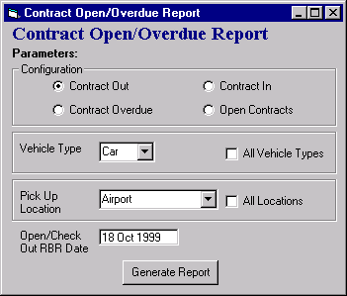
- Configuration selected as “Contract Out”

- Configuration selected as “Contract In”
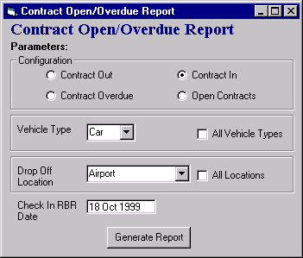

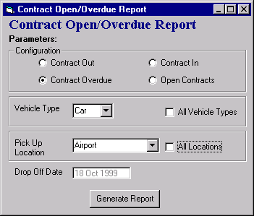
- Configuration selected as “Contract Overdue”

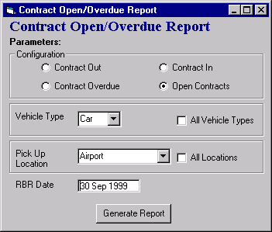
- Configuration selected as “Open Contracts”

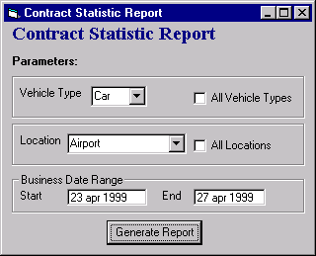
Contract Statistic Report

Daily Contract Transaction Statistic Report

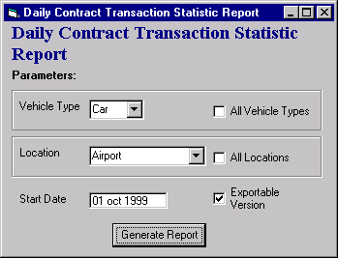

Interbranch Report

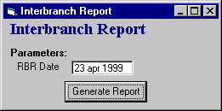
Location End Of Day Reconciliation Report

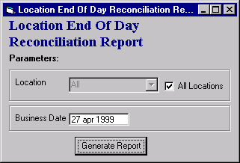

Perfect Driver Point Submission Report
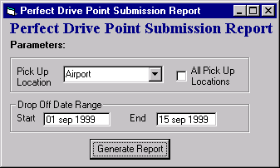

Vehicle Check In Override Report
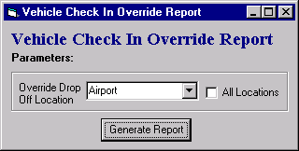

Perfect Driver Point Submission Report

